Reproducing DM-GAN and Testing a
Published MDD Successor
A Controlled 30,000-Sample Evaluation on CUB-200-2011
Final Project Report · Group G_
Course: HSDS-501001
Wenzhe Cao · Jikui Zhou · Xinyi Jiang · Zhongyu Yin
3 September 2026

Final answer: MDD is better under matched mean conditioning; native defaults remain a FID–R trade-off.

1. Introduction
Text-to-image synthesis asks a model to convert language into an image that is both realistic and faithful to the described content [1]. These requirements are not identical: a generator may create a convincing bird while ignoring “black crown,” or show the attribute in an unrealistic image. This distinction matters on CUB-200-2011, where captions often differ through small local details [2]. We therefore treated image quality and text-image agreement as separate objectives.
Our baseline was Dynamic Memory Generative Adversarial Network (DM-GAN), a three-stage conditional GAN [3]. It builds a 64 × 64 image from a sentence embedding and noise, then uses word embeddings in dynamic-memory stages to reach 128 × 128 and 256 × 256. A writing gate selects text in light of the current image, and a response gate controls fusion of retrieved text and image features. The roles of captions, noise, attention, memory, discriminators, and matching losses can therefore be inspected directly.
The final-week question was: does an improvement produce a better model than DM-GAN under a fixed evaluation? An earlier landmark-guided loss improved its directly optimized attention proxy but not generated part-colour relationships. We therefore searched for published methods with official code and weights and evaluated them through one modern pipeline.
The selected method is Modality Disentangled Discriminator (MDD), proposed by Feng et al. [4] and released specifically as a replacement for the discriminators of AttnGAN and DM-GAN [5]. MDD begins from the observation that an image contains text-related content and text-independent style. A conventional discriminator can entangle the two. MDD divides an intermediate discriminator representation into content and style components and applies additional objectives so that the content component is aligned with text while the style component retains information associated with the latent noise. The generator architecture remains DM-GAN-compatible; the improvement is supplied through a more structured training signal from the discriminators.
We selected MDD after testing alternatives. Released DM-GAN plus contrastive learning [6], [7] improved FID but lost substantial R-precision. A corrected-mask sensitivity run of aspect-aware DAE-GAN [8], [9] strongly improved R-precision but produced much worse FID. Our paired local contrastive fine-tuning was inconsistent. Reporting these screens avoids implying that the first attempted idea succeeded.
Our conclusion is deliberately conditional. When both DM-GAN and DM-GAN-MDD use the same deterministic conditioning-augmentation mean, the released MDD checkpoint improves FID and R-precision under our 30,000-sample protocol. When each checkpoint uses its released “native” inference policy—stochastic conditioning for DM-GAN and the mean for MDD—MDD improves R-precision but slightly worsens FID. Thus MDD is supported as the better checkpoint in the controlled matched-mean comparison, but native-mode superiority across every metric is not established.

2. Project Construction / Methods

2.1 Modern baseline implementation
The original repository targets Python 2.7 and PyTorch 0.4 [10]. We reimplemented its core in modern PyTorch while preserving material behaviour. The CUB pipeline reads official splits and captions, uses the provided bounding boxes, and produces images at 64, 128, and 256 pixels. Captions are sorted for the recurrent encoder and restored where required.
Author-released DAMSM encoders from the AttnGAN lineage [11] produce word features [B, 256, T] and a 256-dimensional sentence vector. Conditioning augmentation maps the sentence to 100 Gaussian dimensions. Sample mode returns c = μ + exp(0.5 log σ²) ε; mean mode returns c = μ. The initial generator joins c with 100-dimensional z. Two dynamic-memory blocks use words, a corrected padding mask, memory keys and values, attention, and gates to refine the image to 256 pixels.
Three spectral-normalized discriminators have unconditional real/fake and sentence-conditional heads. Generator training combines adversarial, DAMSM word/sentence matching, and conditioning-augmentation KL losses. The project includes optimizer updates, exponential moving averages, checkpoint conversion, fixed-caption inference, and attention/gate diagnostics. BCEWithLogitsLoss is the stable equivalent of legacy Sigmoid-plus-BCE.
Tests verify shapes, masks, gate ranges, losses, mean conditioning, and checkpoints; a full-channel CUDA smoke test completes both optimizer updates. Released generator, encoders, and statistics load strictly. The Session 6 30,000-sample anchor gave FID 15.7576 and R-precision 76.67% ± 0.83%, close to references 15.34 and 76.58% ± 0.53%. This validates the inference path, not 800-epoch convergence from scratch.

2.2 Published MDD improvement
MDD changes discriminator representations and losses rather than requiring a new generator [4]. At every scale, a 4 × 4 image feature map is split into content and style. Content is projected to the 100-dimensional conditioning space, style matches the dimensionality of z, and standard adversarial heads remain.
Two disentanglement objectives supplement those standard losses. First, a margin-based content objective rewards a higher centered cosine correlation between the generated image’s content code and its correct conditioning code than between a mismatched image code and that condition. In simplified form,
L_content = max(0, m − corr(h_content, c_correct) + corr(h_content_wrong, c_correct)),
where the released implementation uses margin m = 0.5. Second, a style objective encourages correlation between the generated image’s style code and latent noise:
L_style = −corr(h_style, z).
The code also includes a style real/fake adversarial head, weighted 0.1 in the released CUB configuration. These objectives are intended to help the discriminator devote text-related capacity to content matching without discarding text-independent variation. During inference, all discriminators are removed, so the saved MDD generator can be loaded into our same 119-key DM-GAN generator class. We verified a strict load with no missing or unexpected parameters and recorded SHA-256 checksums for every checkpoint and evaluation asset.
The official repository reports CUB changes from FID 16.09 to 15.76, R-precision 72.31% to 79.73%, and legacy Inception Score 4.75 to 4.86 [5]. These motivated, but did not replace, our tests. Released DM-GAN and MDD also differ in batch size and DAMSM loss weight. We compare released models; only identical retraining could isolate the MDD losses causally.

2.3 Candidate screening
We screened three alternatives. The published contrastive approach learns consistent representations from captions of the same image [6]. We strictly loaded its generator and conditioner, but judged both models with separately loaded original DAMSM encoders, preventing evaluation only by the candidate’s modified conditioner.
DAE-GAN extracts attribute-noun phrases and alternates global and aspect-aware local refinement [8]. We used the authors’ aspect metadata and netG_3s. Its repeat-based mask misaligns variable-length captions within a batch, so we implemented the intended batch-major broadcast for a fair shared path. It is not bit-exact to legacy batch-greater-than-one execution.
Local CL2 fine-tuning generated two captions for one image from shared z; NT-Xent aligned their frozen-DAMSM image embeddings. Control and CL2 began from the same generator and cloned state after 200 discriminator warm-up steps, then received 1,200 paired steps. Only the CL2 weight differed; this is not a full reproduction of [6].

2.4 Fixed evaluation protocol and decision rule
Each comparison generated 30,000 256 × 256 images using seed 20260902. We paired caption index and z; two sampling models also shared ε. Outputs used the same Inception extractor, real statistics, frozen original DAMSM scorer, and 99 other-class negatives.
FID measures distributional realism; lower is better [12]. R-precision asks whether the correct caption ranks first among 100 candidates under frozen DAMSM; higher is better. Multiple captions share a CUB image and some rows repeat, so we bootstrap R differences by source-image cluster with 10,000 resamples. McNemar is descriptive only. ImageNet Inception Score is an internal health metric, not comparable to the papers’ CUB classifier.
A candidate passed only if FID was lower and the lower endpoint of the 95% cluster interval for its R difference exceeded −1 percentage point. This non-inferiority allowance accepts a negligible R change but rejects methods that purchase FID by losing substantial semantics.
The primary matched-mean experiment sets conditioning augmentation to μ for both generators. The native-policy sensitivity experiment samples DM-GAN conditioning but uses μ for MDD, following their released evaluation paths. It changes checkpoint and policy simultaneously.

3. Results

3.1 Candidate screening results
Table 1 summarizes why apparently promising methods were not automatically accepted. Deltas are candidate minus the relevant paired control.
The released contrastive checkpoint illustrates why FID alone is insufficient: R-precision falls by 5.55 points, with 95% cluster interval [−6.164, −4.933]. The corrected-mask DAE sensitivity shows the opposite trade-off: R rises 9.70 points, interval [9.135, 10.240], while FID worsens by 6.287. Local CL2 is much closer to its control. Its per-seed R intervals are [−0.117, 0.201], [−0.210, 0.153], and [−0.017, 0.336]. Two seeds pass individually, but one fails; the three-seed FID and R improvements are only 0.0384 and 0.0578 points, with seed-level delta standard deviations 0.0795 and 0.0925. Those standard deviations combine training-seed variation with changes in the evaluation random streams, so they are not estimates of pure training variance. Its aggregate verdict is therefore mixed, so it was not selected. These screens do not show that contrastive or aspect-aware ideas are generally ineffective; they show that these checkpoints or short training did not provide a stable joint improvement here.

3.2 Primary matched-mean MDD result
Under matched deterministic conditioning, DM-GAN-MDD satisfies the predeclared rule. Its FID is 16.1543 versus 17.1708 for DM-GAN, a reduction of 1.0164. R-precision is 79.77% versus 79.10%, an increase of 0.673 percentage points. The paired image-cluster bootstrap interval for the R improvement is [0.134, 1.225] points, entirely above zero and therefore also safely above the −1-point non-inferiority boundary.
Of 30,000 paired caption trials, both models were correct in 20,241 cases, only DM-GAN was correct in 3,488, only MDD was correct in 3,690, and both were wrong in 2,581. These counts show that the 0.67-point R gain is an aggregate result of many disagreements rather than a claim that every MDD sample is better. The FID improvement is distribution-level and cannot be converted into a per-image significance test. Nevertheless, both required directions are favourable under one controlled model-input policy, so the result supports MDD as our final improvement method.

3.3 Native-policy sensitivity result
The native-policy experiment gives a different answer. Stochastic-CA DM-GAN reaches FID 15.7047 and R-precision 76.84%. Mean-CA MDD reaches the same MDD values as above, FID 16.1543 and R-precision 79.77%. MDD therefore gains 2.927 R-precision points, with 95% cluster interval [2.375, 3.485], but worsens FID by 0.4496. Its internal ImageNet IS increases by 0.0741.
This is not a contradiction with the matched-mean result. Sampling conditioning augmentation introduces variation around μ; removing that variation changes the generated distribution even when all weights remain fixed. The stochastic baseline has substantially better FID than its own mean-conditioned version, while its R-precision is lower. The native comparison consequently mixes an inference diversity choice with the learned checkpoint difference. We report it to avoid hiding a realistic deployment choice, but we do not use it as the isolated checkpoint comparison. Under native policies, the honest conclusion is “better semantic agreement with a small realism trade-off,” not “better on all metrics.”

3.4 Overall interpretation
The experiments answer the project question at three levels. First, the baseline reproduction is credible enough for comparison because strict official checkpoints run end-to-end and reproduce the expected metric region. Second, not every method advertised as an improvement remains globally better under a common evaluator. CL and the corrected-mask DAE sensitivity each improved one main axis while failing the other. Third, MDD is the only screened published candidate that satisfies our two-metric rule in the controlled matched-mean test.
The result is consistent with MDD’s intended role. Better discriminator organization during training can leave the unchanged generator with weights that balance visual distribution and caption relevance more effectively. However, checkpoint compatibility is not causal proof. Because the released training configurations differ, the observed 1.016 FID reduction cannot be attributed numerically to one loss term. Because only one checkpoint pair and one generation seed were evaluated, training-run uncertainty is also unknown. The result should therefore be stated as a reproducible checkpoint comparison, not as a new state-of-the-art claim.

4. Conclusion & Future Work
This project constructed a modern, testable DM-GAN pipeline and used it to ask whether a published successor is genuinely better than the baseline. The baseline passed a 30,000-sample reasonableness check against author-provided references. We then screened released contrastive DM-GAN, a corrected-mask DAE-GAN sensitivity, a controlled local CL2 objective, and DM-GAN-MDD with identical evaluators and paired random inputs wherever architectures allowed.
The main result is qualified but useful. DM-GAN-MDD is better than DM-GAN in our primary matched-mean comparison: FID improves from 17.1708 to 16.1543, and R-precision improves from 79.10% to 79.77%, with a 95% source-image-cluster interval of [0.134, 1.225] percentage points for the R difference. This satisfies our joint rule. The native-policy comparison does not establish uniform superiority: MDD improves R-precision by 2.93 points but worsens FID by 0.450. Conditioning policy must therefore be declared whenever these checkpoints are compared.
Several limitations constrain the claim. We evaluated released checkpoints rather than reproducing their full training trajectories. The baseline and MDD weights were trained with partly different configurations, so the experiment compares models as released rather than isolating MDD losses. One seed does not estimate checkpoint-training variance. FID uses a fixed feature model and is distributional; R-precision depends on original DAMSM and sampled negatives. The text conditioner and evaluator belong to the same model family, even though the evaluation modules are separately loaded and frozen. Caption rows from the same CUB image are correlated, and our cluster bootstrap addresses only that sampling dependence. Finally, the corrected modern batch mask is shared and logically intended, but it differs from the author repositories’ faulty batch-greater-than-one mask layout.
Future work should first perform a true controlled retraining: identical initialization, batches, optimizer, DAMSM weight, augmentation, and training length for DM-GAN discriminators versus MDD discriminators across at least three seeds. That experiment would isolate the contribution of modality disentanglement. It should report confidence intervals for R-precision and variability across runs for FID rather than relying on a single checkpoint pair.
Second, conditioning augmentation should be evaluated as a method factor. A two-by-two test—baseline and MDD, each with sampled and mean conditioning—would distinguish diversity effects from checkpoint effects. If stochastic MDD conditioning preserves its R advantage while improving FID, it may produce a stronger deployment setting. Diversity-sensitive measurements such as LPIPS across multiple z and conditioning draws could explain why stochastic baseline conditioning helps FID.
Third, semantic evaluation should become more independent. A frozen bird-part detector, attribute classifier, or blinded human comparison could test local statements such as crown colour and wing pattern without depending only on DAMSM. For aspect-aware models, the evaluator should score whether the correct attribute is attached to the correct part, not merely whether the whole caption ranks highly. This would directly address the original part-aware question that global FID and R-precision only approximate.
Finally, the failed candidates remain informative research directions. The corrected-mask DAE-GAN run’s large R gain suggests that aspect representations carry useful detail, but its FID failure indicates a need for better realism regularization or protocol alignment. The contrastive checkpoint’s FID gain suggests improved visual distribution, but its R loss requires a stronger cross-modal constraint. Longer paired CL2 training, validation-selected loss weights, and independent evaluation may determine whether these trade-offs can be reduced. The central lesson is that “better” must be defined before examining results and must cover both visual quality and text faithfulness. Under that definition, MDD is supported in the matched-mean setting, while the broader claim remains a target for controlled retraining.

Figures and Tables
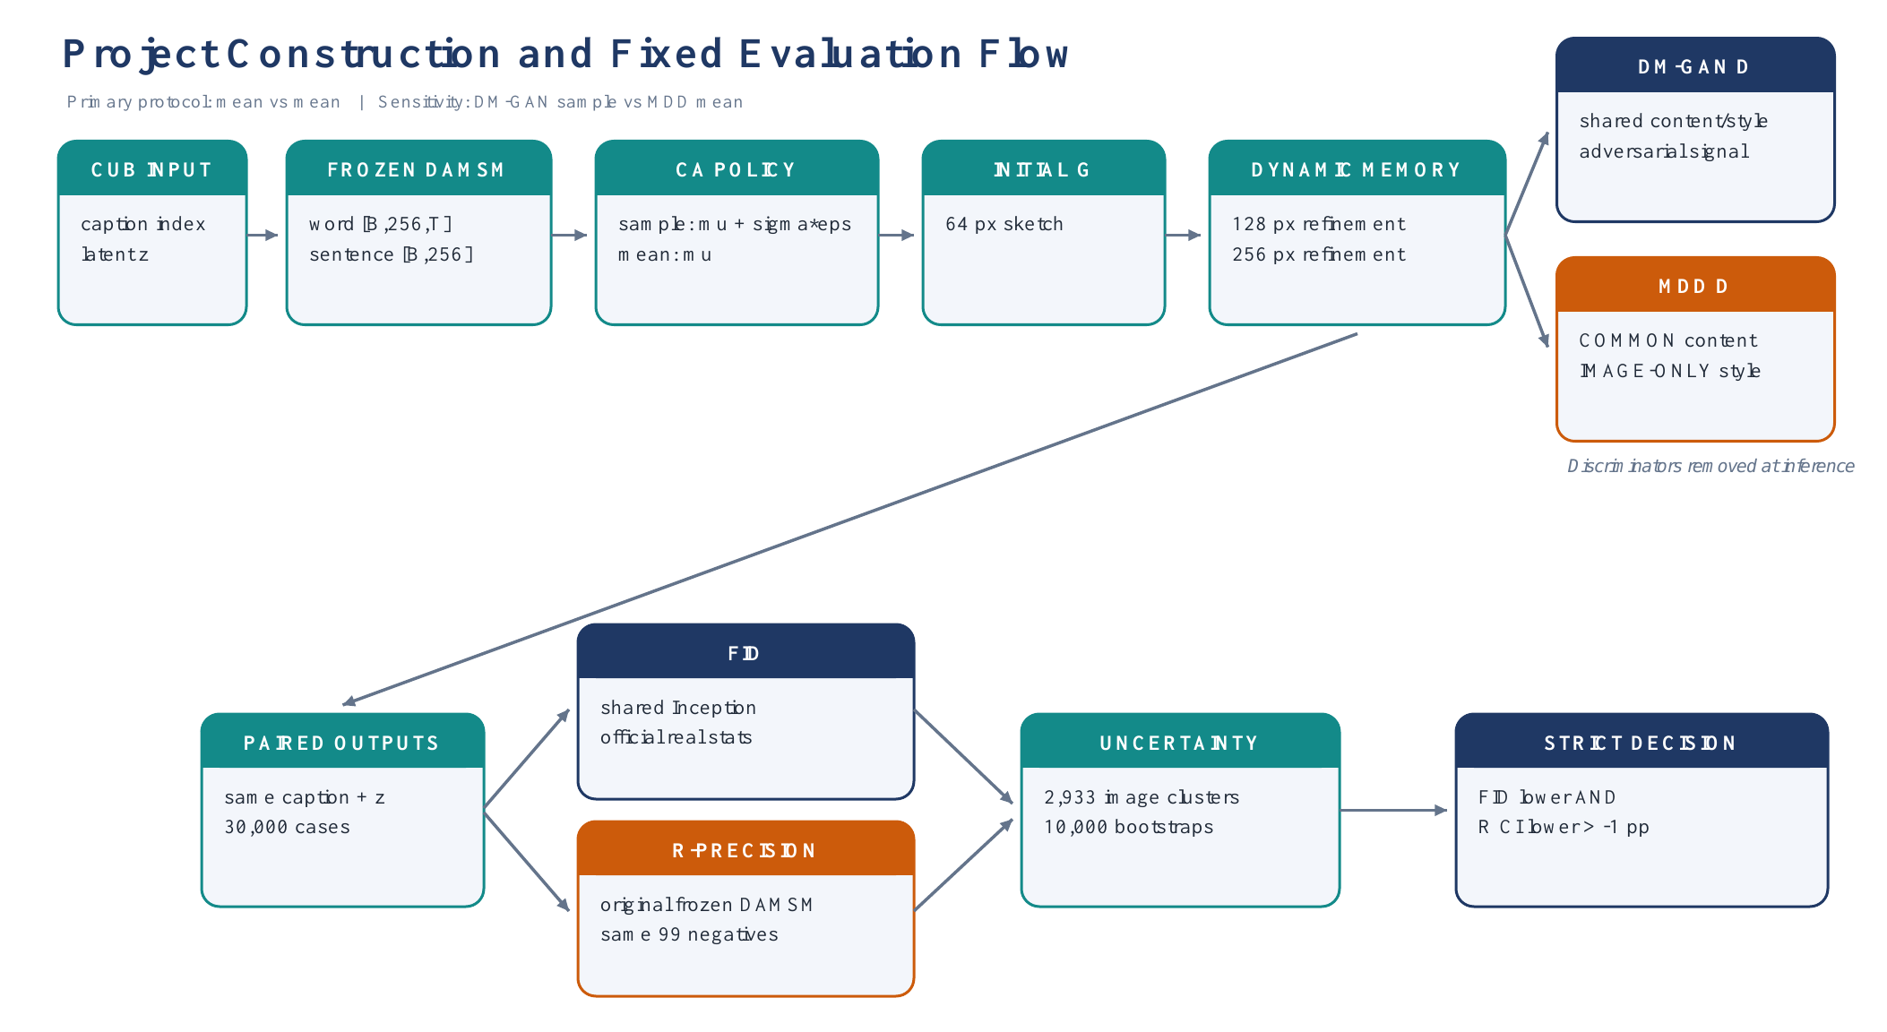
Figure 1. Shared DM-GAN generator path, MDD discriminator difference, and the fixed paired evaluation protocol.

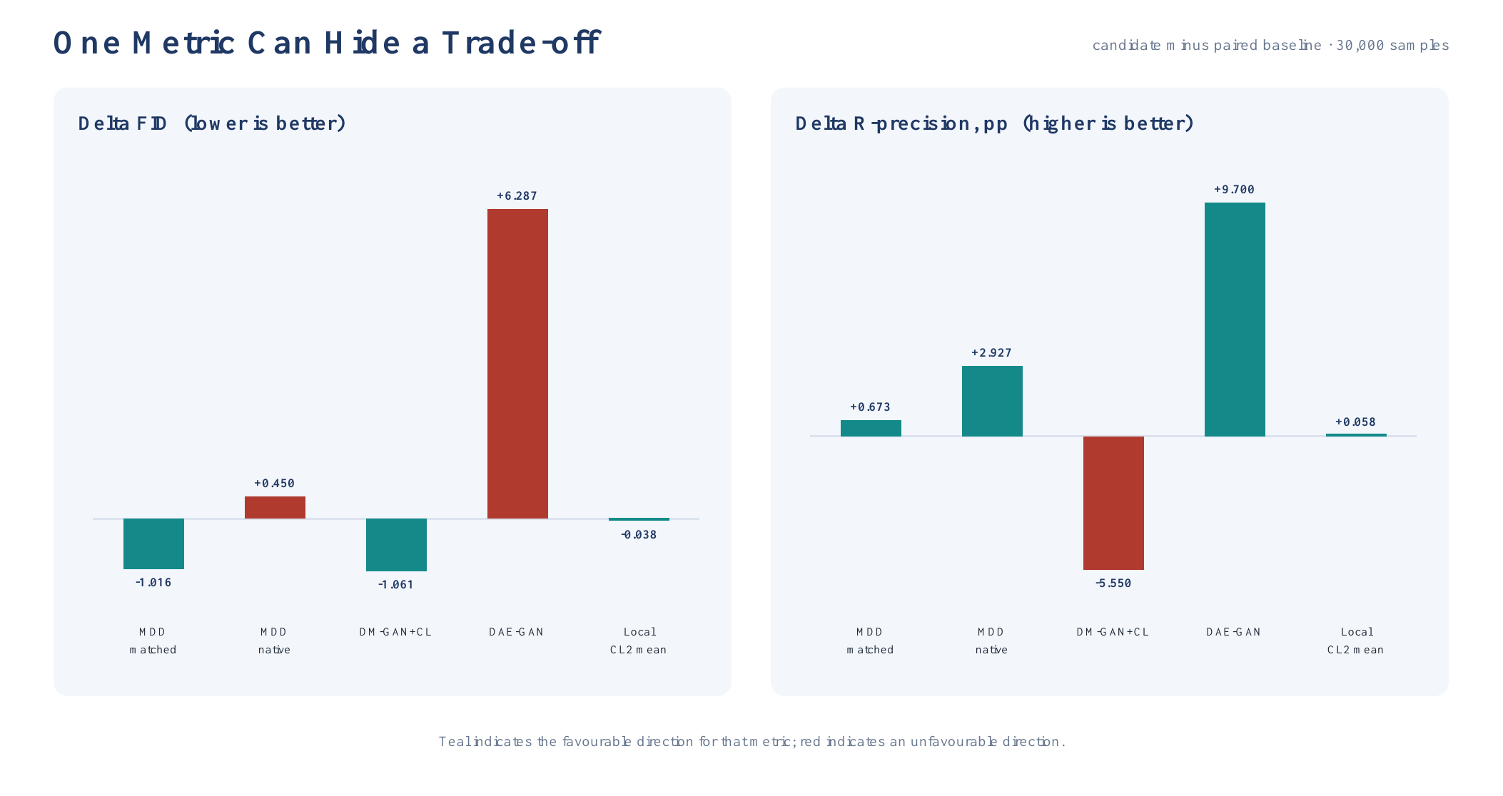
Figure 2. Candidate-minus-baseline deltas. A favourable change in one metric can hide a failure in the other.

Figure 3. Fixed first two paired MDD cases; DM-GAN is left and MDD is right within each pair. Cases are not quality-ranked.

Table 1. Published/local successor screen. Deltas are candidate minus its paired baseline.
Candidate and protocol | Baseline FID | Candidate FID | ΔFID | Baseline R | Candidate R | ΔR | Decision
Released DM-GAN + CL | 15.7047 | 14.6437 | −1.0611 | 76.84% | 71.29% | −5.55 pp | Mixed; semantic loss too large
DAE-GAN `netG_3s`, corrected-mask sensitivity | 15.6693 | 21.9564 | +6.2871 | 76.43% | 86.13% | +9.70 pp | Mixed; FID fails
Local CL2, seed 20260902 | 16.1010 | 16.1541 | +0.0531 | 78.40% | 78.45% | +0.04 pp | Not supported
Local CL2, seed 20260903 | 15.8674 | 15.7770 | −0.0904 | 77.57% | 77.55% | −0.03 pp | Supported for this seed
Local CL2, seed 20260904 | 15.8876 | 15.8098 | −0.0778 | 78.00% | 78.16% | +0.16 pp | Supported for this seed
Local CL2, three-seed mean | 15.9520 | 15.9136 | −0.0384 | 77.99% | 78.05% | +0.06 pp | Mixed across seeds

Table 2. Primary matched-mean MDD result.
Metric | DM-GAN, mean CA | DM-GAN-MDD, mean CA | MDD − DM-GAN | Interpretation
PyTorch FID ↓ | 17.1708 | 16.1543 | −1.0164 | MDD distribution is closer to real CUB statistics
DAMSM R-precision ↑ | 79.10% | 79.77% | +0.67 pp | Small positive semantic change
R difference, 95% cluster CI | — | — | [+0.134, +1.225] pp | Positive under source-image resampling
ImageNet IS ↑ | 5.7822 | 5.7347 | −0.0476 | Small internal-health decline; not paper-comparable

Table 3. Native-policy sensitivity result.
Metric | DM-GAN, native sample CA | MDD, native mean CA | MDD − DM-GAN | Interpretation
PyTorch FID ↓ | 15.7047 | 16.1543 | +0.4496 | MDD fails the FID requirement
DAMSM R-precision ↑ | 76.84% | 79.77% | +2.93 pp | Clear semantic improvement
R difference, 95% cluster CI | — | — | [+2.375, +3.485] pp | Positive under source-image resampling
ImageNet IS ↑ | 5.6606 | 5.7347 | +0.0741 | Small internal-health increase

5. References
[1] S. Reed, Z. Akata, X. Yan, L. Logeswaran, B. Schiele, and H. Lee, “Generative Adversarial Text to Image Synthesis,” in Proceedings of the 33rd International Conference on Machine Learning, 2016, pp. 1060–1069. Paper
[2] C. Wah, S. Branson, P. Welinder, P. Perona, and S. Belongie, “The Caltech-UCSD Birds-200-2011 Dataset,” California Institute of Technology, Technical Report CNS-TR-2011-001, 2011. Dataset page
[3] M. Zhu, P. Pan, W. Chen, and Y. Yang, “DM-GAN: Dynamic Memory Generative Adversarial Networks for Text-to-Image Synthesis,” in Proceedings of the IEEE/CVF Conference on Computer Vision and Pattern Recognition, 2019, pp. 5795–5803, doi: 10.1109/CVPR.2019.00595. Paper
[4] F. Feng, T. Niu, R. Li, and X. Wang, “Modality Disentangled Discriminator for Text-to-Image Synthesis,” IEEE Transactions on Multimedia, vol. 24, pp. 2112–2124, 2022, doi: 10.1109/TMM.2021.3075997. Publisher page
[5] F. Feng et al., “Official DM-GAN-MDD PyTorch Implementation,” GitHub repository. Code and released metrics
[6] H. Ye, X. Yang, M. Takáč, R. Sunderraman, and S. Ji, “Improving Text-to-Image Synthesis Using Contrastive Learning,” in Proceedings of the British Machine Vision Conference, 2021, doi: 10.5244/C.35.137. Paper page
[7] H. Ye et al., “Official T2I Contrastive Learning Implementation,” GitHub repository. Code
[8] S. Ruan, Y. Zhang, K. Zhang, Y. Fan, F. Tang, Q. Liu, and E. Chen, “DAE-GAN: Dynamic Aspect-Aware GAN for Text-to-Image Synthesis,” in Proceedings of the IEEE/CVF International Conference on Computer Vision, 2021, pp. 13960–13969. Paper
[9] S. Ruan et al., “Official DAE-GAN PyTorch Implementation,” GitHub repository. Code
[10] M. Zhu et al., “Official DM-GAN PyTorch Implementation,” GitHub repository. Code
[11] T. Xu et al., “AttnGAN: Fine-Grained Text to Image Generation with Attentional Generative Adversarial Networks,” in Proceedings of the IEEE Conference on Computer Vision and Pattern Recognition, 2018, pp. 1316–1324. Paper
[12] M. Heusel, H. Ramsauer, T. Unterthiner, B. Nessler, and S. Hochreiter, “GANs Trained by a Two Time-Scale Update Rule Converge to a Local Nash Equilibrium,” in Advances in Neural Information Processing Systems 30, 2017. Paper

